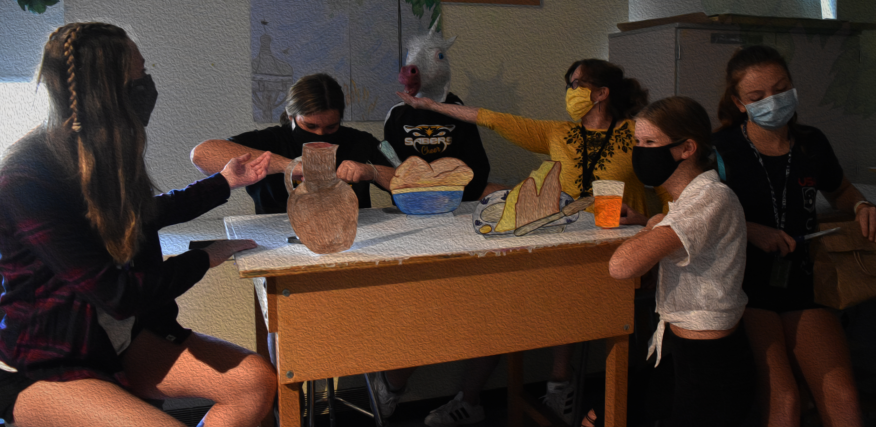

How does art make us human? That is a very good question and there are many ways to answer it. I could say it makes us all individuals, or it gives you a chance to express ourselves. Which are all true but i think that art gives people a chance to get the feelings and emotions out in a nonviolent and beautiful way. Art can be a reflection of a person's thoughts and or personal experiences. And that's what makes us human is the ability to express those emotions. Us as humans are very intelligent and we make beautiful art pieces unlike anything else.

Arts Experience Rubric Era 1 Final

|  |  |  |  |
| --- | --- | --- | --- |
| Standards | Did not achieve (1) | Approaching  Expectations (2) | Meets  Expectations (3) |
| CREATING (Exhibition piece)  Applying the skills and language of a specific arts discipline, students will demonstrate the ability to create in the arts. | Demonstrates a beginning ability to create artistic work. Demonstrates major errors or omissions regarding the simpler concepts and skills | A developing ability to create artistic work. May demonstrate minor errors or omissions regarding the more complex concepts and/ or demonstrates a foundational understanding of how to create art. | Demonstrates the ability to create artistic work. |
| Presenting (Exhibition piece)  Applying the skills and language of a specific arts discipline, students will demonstrate the ability to present in the arts. | Demonstrates a beginning ability to present artistic work. Demonstrates major errors or omissions regarding the simpler concepts and skills | A developing ability to present artistic work. May demonstrate minor errors or omissions regarding the more complex concepts and/ or demonstrates a foundational understanding of how to present in the arts. | N/A |
| Responding  (Artist Statement)  Applying the skills and language of a specific arts discipline, students will demonstrate the ability to respond in the arts. | Demonstrates a beginning ability to respond to artistic work. Major errors, omissions or plagiarism is apparent. | A developing ability to respond thoughtfully to artistic work. May demonstrate a lack of depth to the more complex concepts of responding to art and/ or demonstrates a foundational understanding of how to respond to the arts. | Demonstrates the ability to respond thoughtfully to artistic work. |
| Connecting  (Artist Statement)  Applying the skills and language of a specific arts discipline, students will demonstrate the ability to connect in the arts. | Demonstrates a beginning ability to connect to artists and/ or artistic work. | Demonstrates a developing ability to connect to artists and/ or artistic work. | Demonstrates the ability to connect to artists and artistic work. |